CS 255 System Design Document

UML Diagrams

UML Use Case Diagram
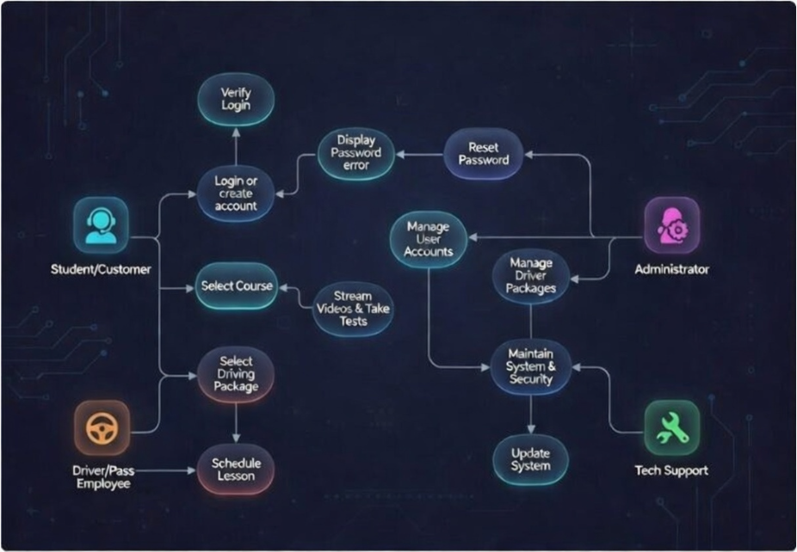

UML Activity Diagrams
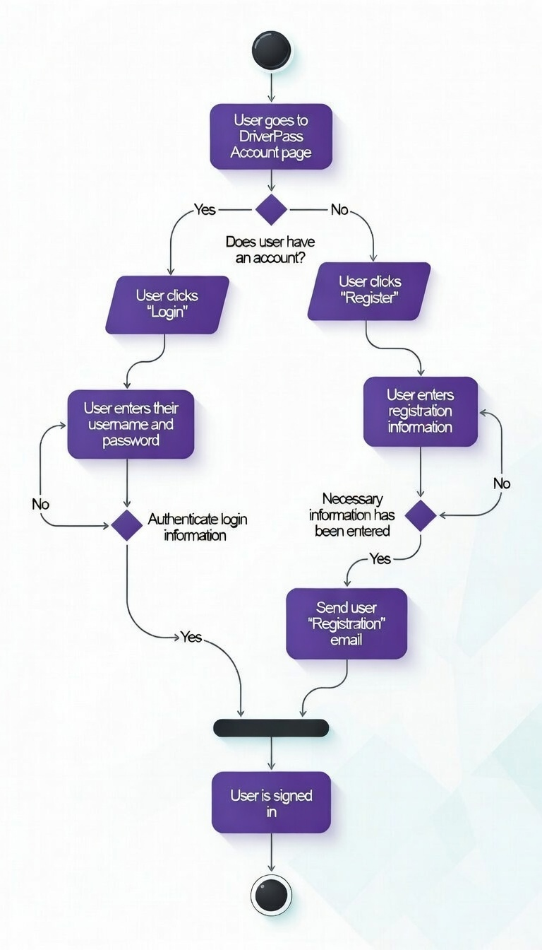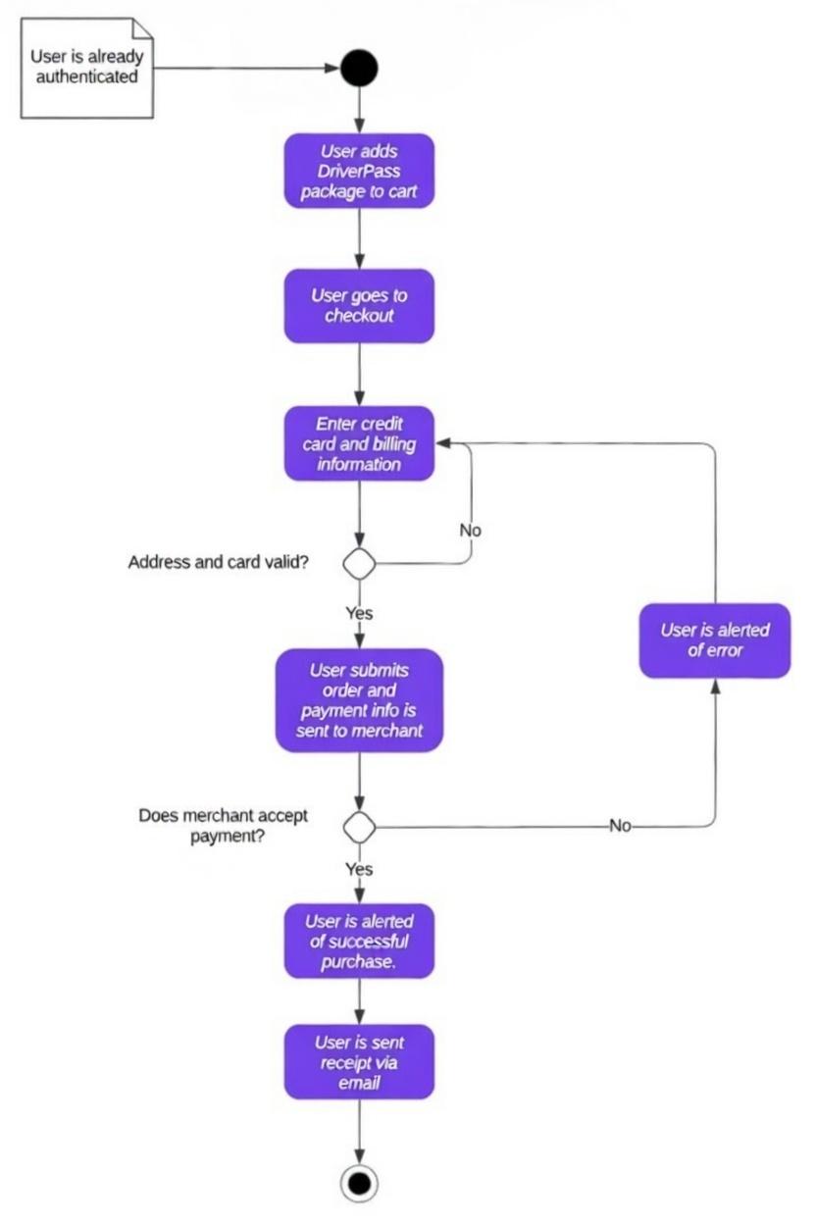

UML Sequence Diagram
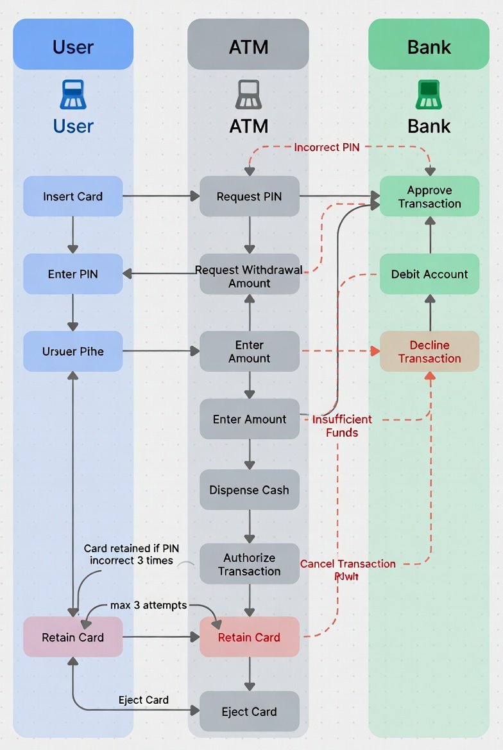

UML Class Diagram
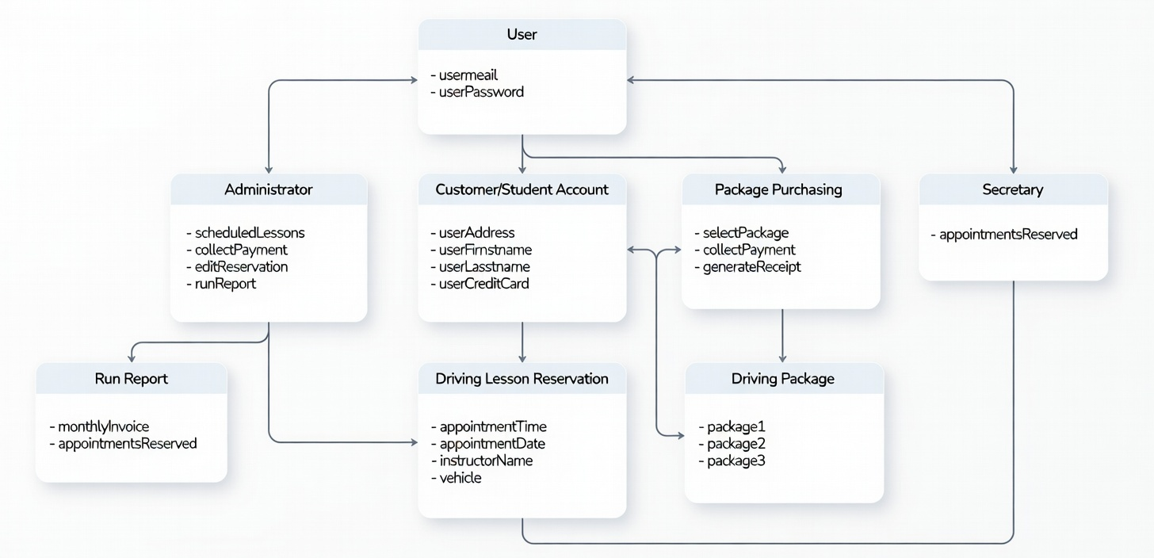

Technical Requirements

Hardware Requirements
- Server: A dedicated or cloud-based server with a multi-core CPU (e.g., 4+ cores), minimum 16 GB RAM, and 500 GB+ SSD storage to manage concurrent user sessions, database queries for lesson reservations, and report generation.
- Client Devices: Standard web-enabled devices including desktops/laptops (minimum 4 GB RAM, modern browser support), smartphones, and tablets for students to access login, view packages, schedule lessons, and make payments; instructors and admins may use office computers for scheduling and reporting.
- Peripherals: Networked printers for generating invoices, receipts, and monthly reports; optional card readers if any in-person payments are supported (though the system emphasizes online card payments).

Software Requirements
- Server Operating System: Linux distribution (e.g., Ubuntu Server) for cost-effectiveness, security, and stability in hosting web applications.
- Web Server: Apache HTTP Server or Nginx to handle HTTP/HTTPS requests and serve the frontend.
- Backend: PHP (with frameworks like Laravel for structured development) or a similar stack to implement business logic for user authentication, package selection, reservations, and reporting, aligning with class operations like selectPackage, callPayment, and runReport.
- Frontend: HTML5, CSS3, JavaScript (with libraries like jQuery or Bootstrap for responsive design and interactive elements such as calendars for appointmentDate scheduling and login forms).
- Database: MySQL or PostgreSQL relational database to store structured data from the Class Diagram, including user credentials (securely hashed), customer details (userAddress, userCreditCard), reservations (appointmentDate, instructorName, vehicle), packages (package1, package2, package3), and financial records.
- Security: SSL/TLS for encrypted connections (HTTPS); libraries for password hashing, session management, and input validation to prevent common vulnerabilities.
- Payment Processing: Integration with third-party gateways (e.g., Stripe, PayPal, or Shift4) to handle card payments securely, supporting approval/decline flows similar to the sequence diagram's transaction logic, with PCI DSS compliance.
- Other: Email service integration (e.g., SMTP or SendGrid) for registration confirmation, payment receipts, and password resets.

Tools Requirements
- Development: IDEs like Visual Studio Code, PHPStorm, or Eclipse; version control with Git.
- Database Management: phpMyAdmin or similar for MySQL administration; tools for schema design based on class entities.
- Testing: Browser developer tools, Postman for API testing (if RESTful endpoints are used), and frameworks like PHPUnit for backend unit tests covering flows like payment validation and reservation conflicts.
- Deployment & Monitoring: Tools like Docker for containerization, CI/CD pipelines (e.g., GitHub Actions), and logging/monitoring (e.g., basic server logs or ELK stack) for tracking errors in authentication or scheduling.

Infrastructure Requirements
- Hosting: Cloud platform such as AWS, Azure, or a VPS provider for scalability, automatic backups, and high availability (99.9%+ uptime) to support real-time lesson scheduling and payment processing.
- Network: Reliable internet with firewall protection; load balancing if user traffic grows; secure VPN access for administrators managing reports or updates.
- Security & Compliance: Role-based access control (RBAC) to restrict actions (e.g., only admins run reports, students view own reservations); data encryption for sensitive fields like credit card info; regular backups and disaster recovery; adherence to PCI DSS for payments and general data protection regulations.
- Scalability: Auto-scaling capabilities for peak times (e.g., seasonal enrollments); support for future additions like vehicle management or instructor assignment logic implied in reservations.

